A Project Report

On

**PROJECT - II**

BY

**RAHUL MATHEW**

**2019B5A41398H**

Under the supervision of

## **Dr Nirman Ganguly**

**(Faculty, Dept of Mathematics.)**

**SUBMITTED IN PARTIAL FULFILMENT OF THE REQUIREMENTS OF**

**MATH F424: Applied Stochastic Process (2nd Sem. 2022-23)**



**BIRLA INSTITUTE OF TECHNOLOGY AND SCIENCE PILANI (RAJASTHAN)**

**HYDERABAD CAMPUS**

**(April 2023**)

**CONTENTS**

1. Options
2. Factors Influencing Option Pricing
3. Black Scholes Model
4. Black-Scholes for European Option
5. Black-Scholes for American Options
6. References

**Options**

## **What is an options contract?**

Options are a legal contract between two parties to buy or sell an asset at a fixed time at a fixed price. An asset could be anything from a stock (e.g. RIL), index (e.g. NIFTY, BANKNIFTY), commodity (e.g. Gold), currency (e.g. USD INR) and so on.

**Why is it called an option?**

An option buyer has a right but not an obligation to buy or sell an asset at a future date. If there is no choice, then it becomes a future contract.

**Two types of Options**

There are two types of options — call & put. A call option gives a buyer a right to buy an asset at a fixed price on a future date but not an obligation.

Put option gives a buyer a right to sell an asset at a fixed price on a future date but not an obligation.

## 

## 

## 

## 

## **Option Contract**

Here’s how a basic options contract is quoted

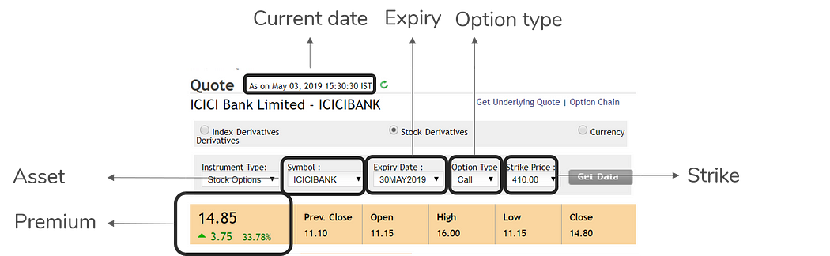

**Symbol:** Here, the asset mentioned is ICICI Bank stocks. The asset can be stock, commodity, gold, etc.

**Expiry Date**: 30th May 2019 - refers to the date when the option holder has a right to exercise the option to buy or sell the underlying asset.

**Option Type**: Call or Put option

**Strike**: Refers to the price at which the option holder may buy (in case of a call option) or sell (in case of a put option). Here the price is Rs. 410.

**Premium**: Amount paid to buy one options contract. Here it is Rs. 14.85.

A person can either buy an asset or sell the asset. If you want to sell an asset, you will want to maximise your profits and minimise your losses. The same is the case with buying.

**Call Option Buyer**

A call option buyer has a right but not an obligation to buy the asset at the strike price on or before the expiration date.

To minimise losses while buying an asset, you can buy a **call option** at a **premium** on that asset at a **strike price**. If the price falls below the strike price, you can buy the asset else, you have the option to back out of the deal. But if the price of the asset keeps increasing, you can still buy the asset and sell it later for the market price, thereby making a profit.

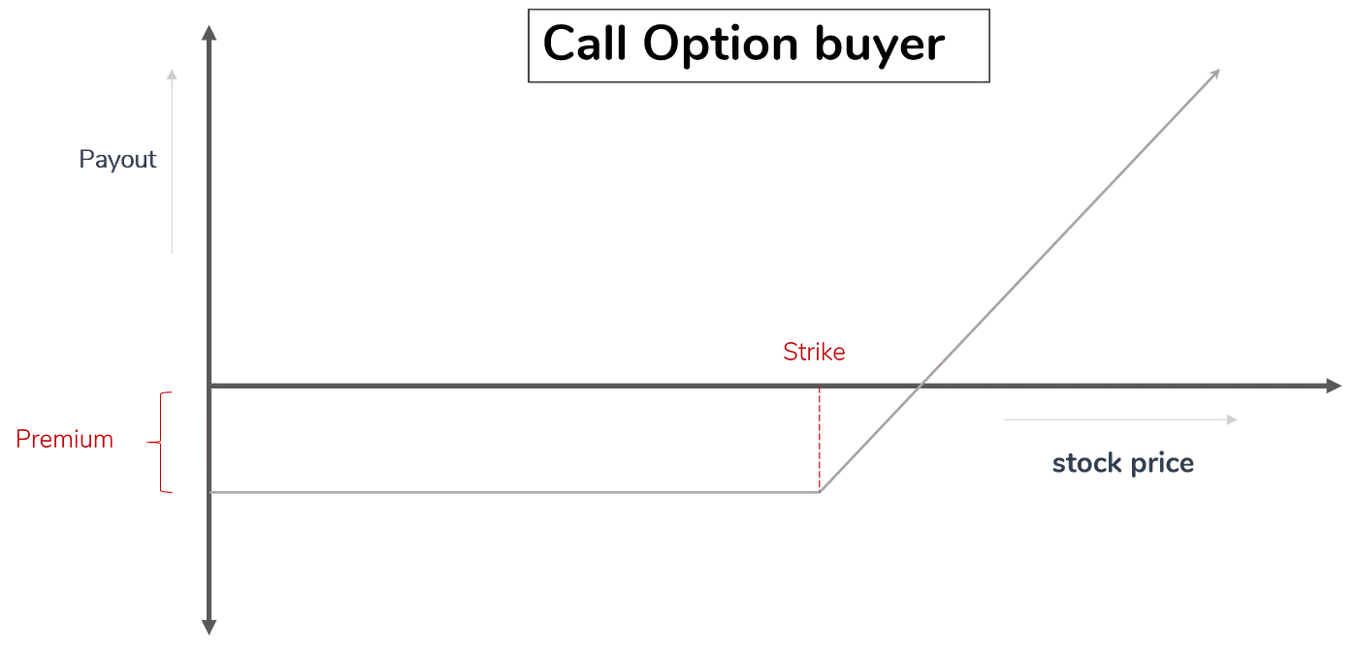

Call option buyer pays an upfront premium, and the maximum loss is capped at the premium. But the maximum profit is unlimited.

Call option buyers theoretically have an unlimited upside.

Call Option buyer Payoutat expiry = max(Stock Priceat expiry - Strike Price, 0)

Call Option buyer Profitat expiry = max(Stock Priceat expiry - Strike Price, 0) - Premium

## 

## **Put option buyer**

A Put option buyer has a right but not an obligation to sell an asset at the strike price on or before the expiration date.

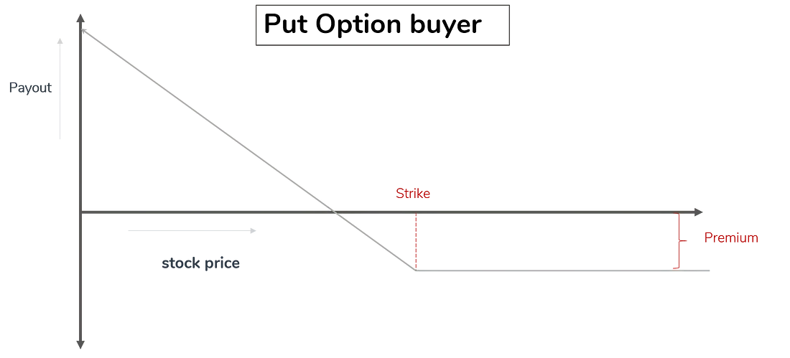

A put option pays out if the stock price on the expiry date is less than the strike price. Since a put option buyer will sell stock only when the strike price is higher than the stock price on that day, the put option payout will be the difference between the strike price and stock price if the stock price is less than the strike price, and zero otherwise.

Put option buyers have limited upside and downside. They make a profit when the price falls.

Put Option buyer Payoutat expiry = max(Strike Price - Stock Priceat expiry , 0)

Put Option buyer Profitat expiry = max(Strike Price - Stock Priceat expiry , 0) - Premium

## 

## 

## **Factors that influence option pricing**

1. **Strike Price**: Farther the strike price, the lesser the likelihood that the current stock price ends above the strike (for call option) or below the strike (for put option). Since this option is less likely to pay on the expiry date, we should intuitively expect the price we pay today to be lower.
2. **Time to Expiry**: Greater the time to expiry, the higher the likelihood of the stock price going beyond the strike price. As the time to expiry increases, the chance of sudden black swan events (e.g., a trade war between the US and China, a major Brexit announcement, demonetisation etc) also increases. When there are sudden large movements in stock price, an option buyer could see a huge increase in price.
3. **Volatility**: Higher volatility increases the likelihood of a huge swing in the stock price in either direction. The potential of a huge movement away from the stock price increases the likelihood of the stock price going beyond the strike price. High volatility increases the price of options.
4. **Risk-free Interest rates**: The risk-free rate represents the interest an investor would expect from an absolutely risk-free investment over a specified period of time. Government bond yield over a period of time is generally considered as the Risk-free rate.
5. **Dividend yield**: Dividend yield = (Annual Dividend per share / Stock Price)*100. A higher dividend in future will reduce the stock price, all other things being equal ( To avoid arbitrage, markets tend to reduce stock price as soon as a dividend is announced by a company). A drop in stock price increases the value of put option and reduces the value of a call option.

## 

## 

## **Black Scholes Model**

The Black-Scholes model makes the following assumptions:

1. The stock price follows a log-normal distribution.

2. The risk-free interest rate is constant and known.

3. The volatility of the stock price is constant and known.

4. There are no transaction costs, taxes, or dividends during the option's life.

5. The option can be exercised only at maturity (European option).

6. The market is frictionless, meaning there are no restrictions on short selling, no margin requirements, and no restrictions on the amount of money that can be invested.

These assumptions are simplified approximations of the real world and may not always hold true. However, the Black-Scholes model provides a useful framework for understanding the behaviour of options in financial markets.

Here I will look at two options:

* **European Option**: It can only be exercised on the expiration date.
* **American Option**: It can be exercised anytime before the expiration date.

According to the Black-Scholes model



S(t) is the price of the asset, μ is the measure of the average rate of growth of the asset price, also known as the drift, and σ is volatility, which measures the standard deviation of the returns (both assumed to be constant), and X= X(t) is standard Brownian motion.

Solving the above Stochastic PDE using Ito’s Calculus, we get the famous

**Black Scholes Partial Differential Equation.**

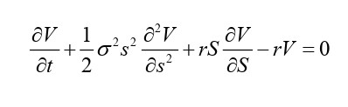

Where V(S,t) is the option, and it depends only on S, t.

r is the risk-free interest rate. If we subtract dividend yield q from r (r - q), we can use black scholes for assets with dividends.

**Black-Scholes for European Options**

C(S, T) = max(S - K, 0)

C(S, t) is the European call with expiry date t and strike price K.

Our “spatial” or asset-price boundary conditions are applied at zero asset price, S = 0, and at S → ∞. We can see from that if S is ever zero then dS is also zero and therefore S can never change. This is the only deterministic case of the stochastic differential equation . If S = 0 at expiry, the payoff is zero. Thus the call option is worthless on S = 0 even if there is a long time to expiry. Hence on S = 0 we have

C(0, t) = 0

As the asset price increases without bound it becomes ever more likely that the option will be exercised and the magnitude of the exercise price becomes less and less important.

Thus S → ∞, C(S, t) ∼ S

These two will be the boundary conditions to solve the PDE for the Call option.

For a put option, with value P(S, t), the final condition is the payoff

P(S, T) = max (K - S, 0).

We have already mentioned that if S is ever zero then it must remain zero. In this case the final payoff for a put is known with certainty to be K. To determine P(0, t) we simply have to calculate the present value of an amount K received at time T. Assuming that interest rates are constant we find the boundary condition at S = 0 to be



As S → ∞ the option is unlikely to be exercised and so

P(S, t) → 0as S → ∞ .

Solving for both cases with the interest rate r, dividend yield q and volatility to be constant.

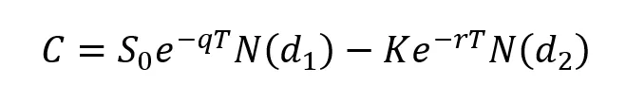

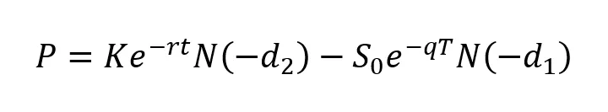

Where N() is the standard normal distribution function - N(0,1) and d1 and d2 are

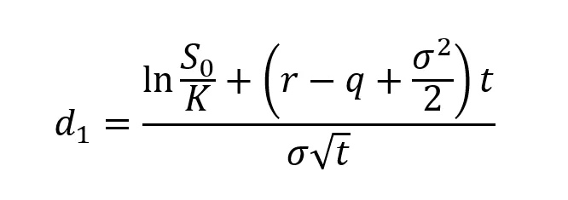

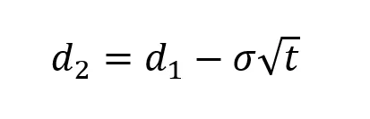

**Black-Scholes for American Options**

For the American Option let’s start with



Here μ is the expected return of the stock

μ = r - q + σ2/2

Where

r = risk free rate of the market

q = dividend yield of the stock

σ = volatility of the stock

dX(t) is a brownian motion that means that every increment belongs to the normal distribution N(0, dt) where dt is the time increment.

Xt+dt - Xt ~ N(0, dt)

Which implies that,

dX(t) ~ √dt * N(0, 1)



Expanding the above equation,

S(t + dt) - S(t) = μS(t)dt + σS(t)dX(t)

Rearranging

S(t + dt) = μS(t)dt + σS(t)dX(t) + S(t)

S(t + dt) = [μdt + σdX(t) + 1]S(t)

Here, dX(t) ~ √dt * N(0, 1)

dt is the time increment. dX(t) can be replaced by a new Random Variable Z ~ √dt * N(0, 1).

The above equation can be used in Monte Carlo simulation to simulate a bunch of price paths for the stock. For each price path calculate the Option prices using,

C(S, T) = max(S - K, 0) and

P(S, T) = max (K - S, 0)

Take the average of all the option prices throughout all the paths, that will be optimal price for the option.

Once the optimal price is found, optimal exercising time can also be calculated.

For the call option, higher the stock price, higher the payoff.



Therefore among each price path find out the highest stock price and note down the time taken to reach the highest stock. Calculate the optimal time for each price path and take a mean across all the optimal times. The mean will be the optimal exercising time for that call option.

A similar approach can be used for Put option as well.

For the put option, lower the stock price, higher the payoff.



Similar to earlier approach, find out the lowest stock price in each price path and the time taken to reach there. That will be the optimal time for the put option for that path. Repeat this process for all of the paths and calculate the mean. That will be the optimal exercising time for that Put option.

Link to the program:

[Options Pricing](https://colab.research.google.com/drive/1gIpCTm1C6nyXLiAvnUqV9Hc6vg4ifoeh?usp=share_link)

**References:**

1. [BigBlind – Medium](https://medium.com/@bigblind)
2. [Microsoft Word - 初稿11 ing (diva-portal.org)](https://www.diva-portal.org/smash/get/diva2:301061/FULLTEXT01.pdf)
3. <https://towardsdatascience.com/systematically-pricing-financial-options-with-black-scholes-4998c591ccbd>
4. [ch_20_option.PDF (uh.edu)](https://uh.edu/~ghong/fina6335/ch_21.PDF)
5. [BrownianMotionCurrent.pdf (uchicago.edu)](https://galton.uchicago.edu/~lalley/Courses/313/BrownianMotionCurrent.pdf)